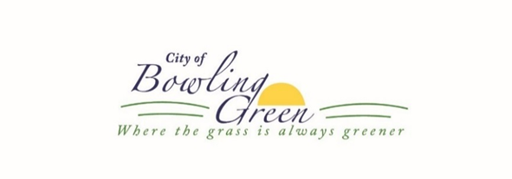
LIQUOR LICENSE APPLICATION

Email- The completed application can be emailed to bgcityhall@bowlinggreen-mo.gov
Or can be mailed/dropped off at:
City Hall- 16 West Church St. Bowling Green, MO 63334 (573)324-5451

INSTRUCTIONS
- Submit completed application to the City Clerk with payment of required license fee(s).
- Answer all questions fully or indicate N/A if not applicable.
- Attach copies of any additional supporting documentation if requested.
- If the establishment is a corporation and/or a partnership, please provide a list of names, address, and date of birth of Corporate Officers/Partners.
- If a new license, applicant must apply for a City Business License prior to issuance of a liquor license.
- If a renewal license, applicant must obtain a City Business License prior to the issuance of a liquor license.
- All other types of liquor licenses not listed, please contact the City Clerk.
- No guarantee of issuance with payment. If license is not granted, the license fee shall be refunded to the applicant.
- All documentation along with full payment must be received before the application will be processed.

COMMONLY ASKED QUESTIONS
- Liquor Licenses are due annually and the term runs from July 1 through June 30, the following year. Excluding Caterers Permit.
- If license is issued in the middle of the term, fees will be prorated. The applicant will need to reapply at renewal time. Please contact the City Hall to find out the prorated amount before submitting the application.
- If this is a new license, the applicant will need to obtain a State Liquor License first. Applicant will also need to obtain a license from Pike County Clerk’s office.
- Special Events often require special permits and requests. Please contact the City Clerk to see if your event/liquor license request will require any special permits.

APPLICATION FOR LIQUOR LICENSE ____NEW ____RENEWAL

Type of License

______$450.00 Liquor (all kinds) by the drink ______ $37.50 Tasting permit
______ $150.00 Liquor (all kinds) original package ______ $15.00 Caterers permit per day
______ $75.00 Beer and wine by the drink ______ Other (Check with City Clerk)
______ $37.50 Temporary permit by the drink (7 day max)
Designate Number of Days

_____ 6 days per week
_____ 7 days per week-Sunday Sales (Additional Fee $300.00)

Business Name: ____________________________________________________________________________________
Physical Business Address: ___________________________________________________________________________
Mailing Address: ___________________________________________________________________________________
Owner’s Name: ____________________________________________________________________________________
Owner’s Address: ___________________________________________________________________________________
Phone Number: _______________________________________ Cell: ________________________________________
Applicant/Manager Name:____________________________________________________________________________
Applicant’s Phone Number ___________________________________________________________________________
Applicant’s DOB: _____________________________________ Applicant’s SSN _______________________________
Is the Applicant a United States citizen? ______ YES ______ NO
Is the Applicant a taxpaying citizen of the County, Town, City or Village where you reside in the State? ____ Y ____ N
Has a license held by the owner/applicant for the sale of intoxicating liquor or non-intoxicating beer ever been revoked?
____ YES ____ NO If yes, give time and place: _________________________________________________________
Has the owner/applicant ever been convicted of any law applicable to the manufacture or sale of intoxicating or non-intoxicating beer since the ratification of the Twenty-first Amendment of the Constitution of the United States?
____ YES ____ NO If yes, give time and place: _________________________________________________________
Does the Applicant agree to abide by all liquor laws of the State of Missouri? _____ YES _____ NO
I _____________________________________ Owner/Applicant hereby consent to a complete criminal record check.
It is understood and agreed that the City of Bowling Green, MO license herein applied shall not be in force and effect until such time as all State permits and licenses are issued to the applicant herein for premises above described. It is further understood and agreed that the license, when and if issued, shall be subject to revocation for cause by the Board of Alderman, and when and if lawfully revoked for cause, no part of the fee hereunder shall be returned to the applicant.
_________________________________________
Signature of Owner/Applicant

